
QUES: CREATE DATABASE?
mysql> create database assignment1;
Query OK, 1 row affected (0.03 sec)

mysql> use assignment1;
Database changed
QUES1:
mysql> create table countries(country_id int,country_name varchar(40),region_id int);
Query OK, 0 rows affected (0.03 sec)
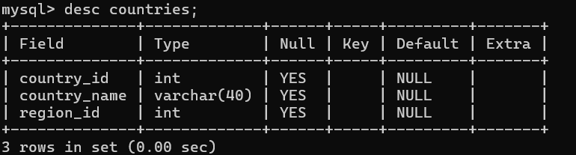

QUES2:
mysql> create table if not exists countries(country_id int,country_name varchar(40),region int);
Query OK, 0 rows affected, 1 warning (0.01 sec)
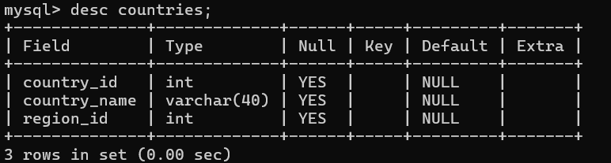

QUES3:
mysql> create table dup_contries like countries;
Query OK, 0 rows affected (0.08 sec
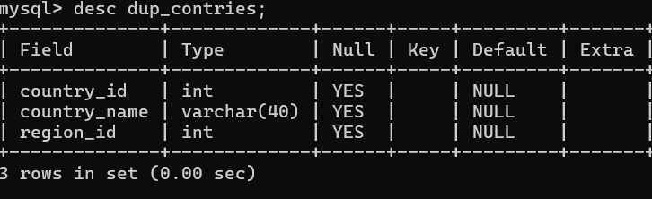

QUES4:
mysql> create table dup_countries as select * from countries;
Query OK, 0 rows affected (0.09 sec)
Records: 0 Duplicates: 0 Warnings: 0
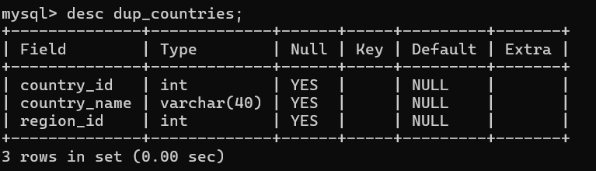

QUES5:
mysql> create table countries1(country_id int null,country_name varchar(40) null,region int null);
Query OK, 0 rows affected (0.08 sec)
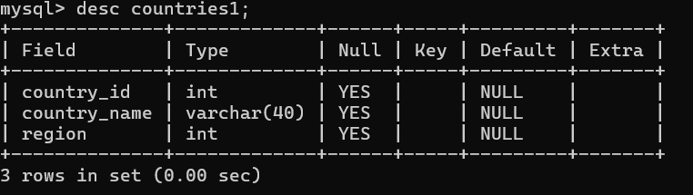

QUES6:
mysql> create table jobs(job_id varchar(10),job_title varchar(35),min_salary decimal(6,0),max_salary decimal(6,0),check(max_salary<=25000));
Query OK, 0 rows affected (0.04 sec)
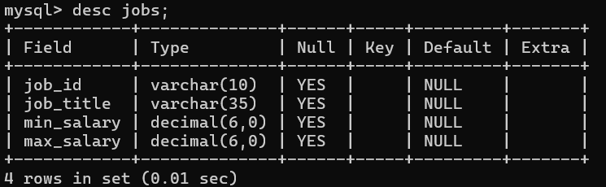

QUES7:
mysql> create table countries2( country_id int,country_name varchar(40),region_id int,check(country_name in('italy','india','china')));
Query OK, 0 rows affected (0.0 sec)
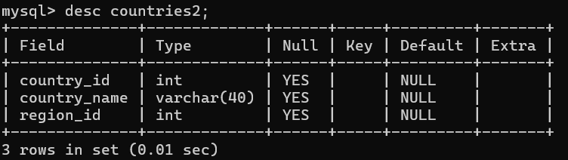

QUES8:
mysql> create table job_history(employee_id int,start_date date,end_date date,job_id varchar(10),department_id int);
Query OK, 0 rows affected (0.04 sec)

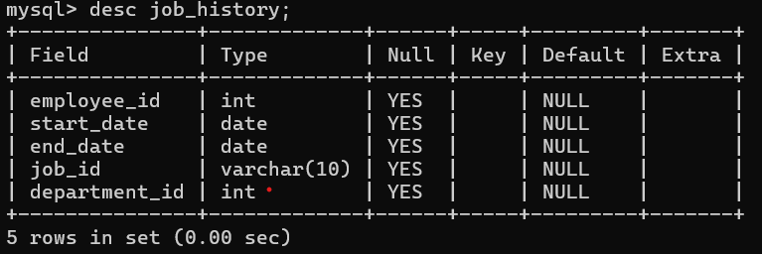

QUES9:
mysql> create table countries4(country_id int unique,country_name varchar(40),region_id int);
Query OK, 0 rows affected (0.09 sec)

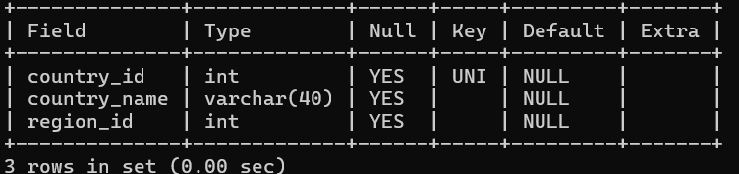
QUES10:
mysql> create table jobs1(job_id int not null unique primary key,job_title varchar(35) not null default'',min_salary decimal(6,0) default 8000,max_salary decimal(6,0) default null);
Query OK, 0 rows affected (0.09 sec)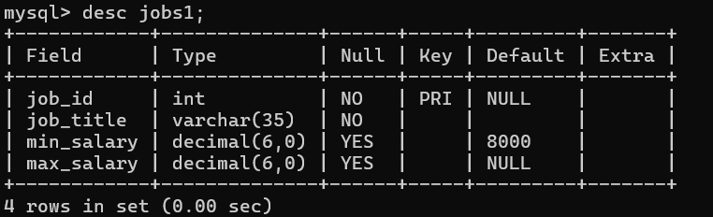

QUES11:
mysql> create table countries5(country_id int primary key,country_name varchar(40),region_id int);
Query OK, 0 rows affected (0.09 sec)
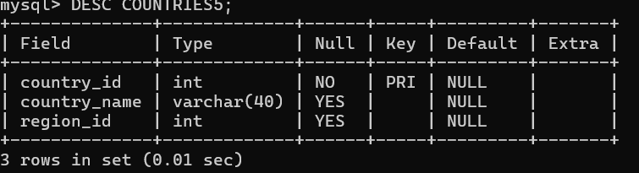

QUES12:
mysql> create table countries6(country_id ,int auto_increment unique, country_name varchar(40), region_id int);
Query OK, 0 rows affected (0.05 sec)

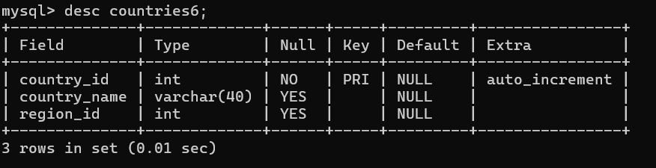

QUES13:
mysql> create table countries7(country_id int, country_name varchar(40), region_id int,unique(country_id,region_id));
Query OK, 0 rows affected (0.06 sec)
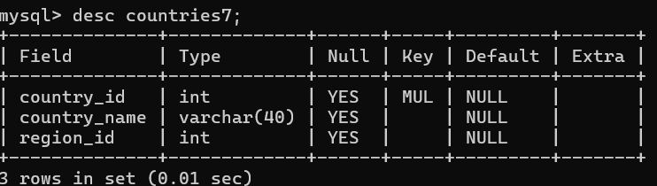
QUES14:
Create_Job_History

Query OK, 0 rows affected (0.06 sec)

QUES15:
Create_Employees_Composite_FK

Query OK, 0 rows affected (0.06 sec)

QUES16:
create_employees_table
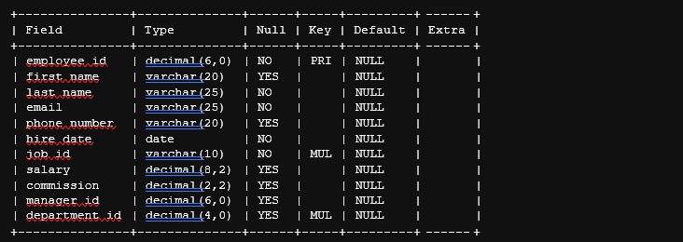

QUES17:
create_employees_table


QUES18:
create_employees_table


